Mathematics
BECE 2019 — Paper 1 (Objective)
1. Given that A = {2, 4, 6, 8, 10} and B = {4, 8, 12}, find A∪B.
A. {4, 8}.
B. {2, 8, 12}.
C. {4, 6, 8, 12}.
D. {2, 4, 6, 8, 10, 12}.
2. Express 0.000344 in standard form.
A. 3.44 × 10⁻⁶.
B. 3.44 × 10⁻⁵.
C. 3.44 × 10⁻⁴.
D. 3.44 × 10⁻³.
3. Which of the following numbers is the largest?
A. −70.
B. −50.
C. −3.
D. −2.
4. Correct 0.024561 to three significant figures.
A. 0.03.
B. 0.025.
C. 0.0245.
D. 0.0246.
5. Simplify: (7⁵ × 7³) ÷ 7⁶.
A. 7⁹.
B. 7⁴.
C. 7³.
D. 7².
6. How many lines of symmetry has a square?
A. 0.
B. 1.
C. 2.
D. 4.
7. Solve the equation 10 − (x + 3)/2 = 8.
A. −9.
B. −3.
C. 1.
D. 15.
8. Factorize: kx + 2xt − 4k − 8t.
A. (k − 2t)(x + 4).
B. (k + 2t)(x + 4).
C. (k + t)(x − 4).
D. (k + 2t)(x − 4).
9. There are 12 boys and 18 girls in a class. Find the fraction of boys in the class.
A. 2/5.
B. 3/5.
C. 2/3.
D. 3/4.
10. Express 30% as a fraction in its lowest term.
A. 7/10.
B. 3/20.
C. 7/20.
D. 3/10.
11. Make k the subject of the relation, ky − k = y².
A. k = y²/(y − 1).
B. k = y²/(y + 1).
C. k = −y²/(y + 1).
D. k = (y² + 1)/(y − 1).
12. The mean of the numbers 5, 2x, 4 and 3 is 5. Find the value of x.
A. 3.
B. 4.
C. 5.
D. 8.
13. The mapping below shows the relationship between x and y:
x: 1 2 3 4 5
y: 3 1 −1 −3 −5
Find the rule of the mapping:
A. y = 2x + 2.
B. y = −2x + 2.
C. y = 4x.
D. y = −2x + 5.
14. The two sides of a parallelogram are 4.8 m and 7.2 m long. Find its perimeter.
A. 48.0 m.
B. 34.6 m.
C. 24.0 m.
D. 17.3 m.
15. A tank in the form of a cuboid has length 6 m and breadth 4 m. If the volume of the tank is 36 m³, find the height.
A. 0.67 m.
B. 1.5 m.
C. 1.8 m.
D. 5.0 m.
16. If the bearing of A from B is 240°, find the bearing of B from A.
A. 040°.
B. 060°.
C. 120°.
D. 300°.
17. Find the truth set of the inequality 2y + 5 < 4y − 5.
A. {y: y > 5}.
B. {y: y < 5}.
C. {y: y > 1}.
D. {y: y > 0}.
18. Find the gradient of the straight line which passes through the points (−3, 4) and (3, −2).
A. 2.
B. 1.
C. −2.
D. −1.
19. If 6:8 = r:48, find the value of r.
A. 36.
B. 34.
C. 14.
D. 12.
20. In the diagram, PSR is a straight line, PQ = QS (tick-marked) and SQ = QR (tick-marked); the angle at R (∠SRQ) is 35°. Find ∠QPS in the diagram.
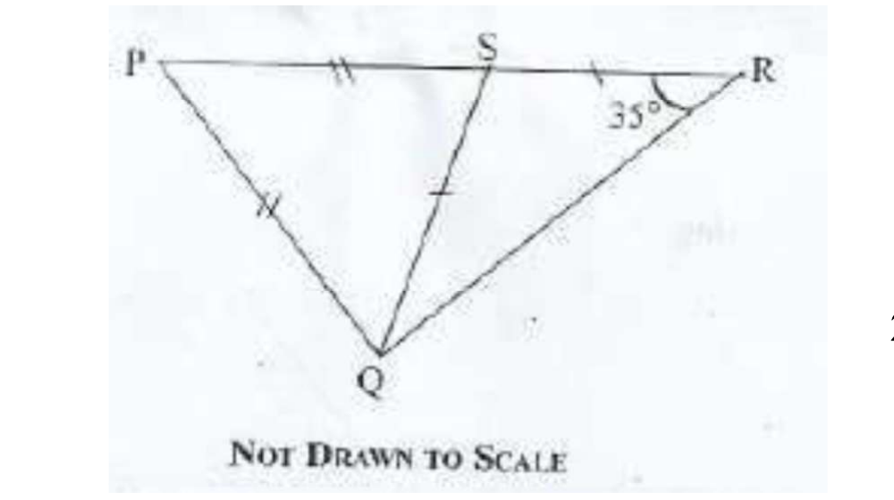
A. 70°.
B. 40°.
C. 35°.
D. 20°.
21. A man travelled a distance of 8 km in an hour. How long will it take him to cover a distance of 12 km, travelling at the same speed?
A. 1 1/3 hrs.
B. 1 1/2 hrs.
C. 1 3/4 hrs.
D. 2 hrs.
22. A number is selected at random from: 25, 26, 27, 28, ..., 35. Find the probability that the number selected is a prime number.
A. 6/11.
B. 3/11.
C. 2/11.
D. 1/11.
23. Express 12/25 in decimal fraction.
A. 0.0408.
B. 0.048.
C. 0.408.
D. 0.48.
24. Find the diameter of a circle whose circumference is 88 cm. [take π = 22/7]
A. 14 cm.
B. 22 cm.
C. 28 cm.
D. 20 cm.
25. When twelve is subtracted from three times a certain number and the result is divided by four, the answer is eighteen. Find the number.
A. 84.
B. 40.
C. 28.
D. 20.
26. In the diagram, line MN is parallel to line TU, line TS cuts line MN at O and ∠MOS = 115°. Find ∠OTU.
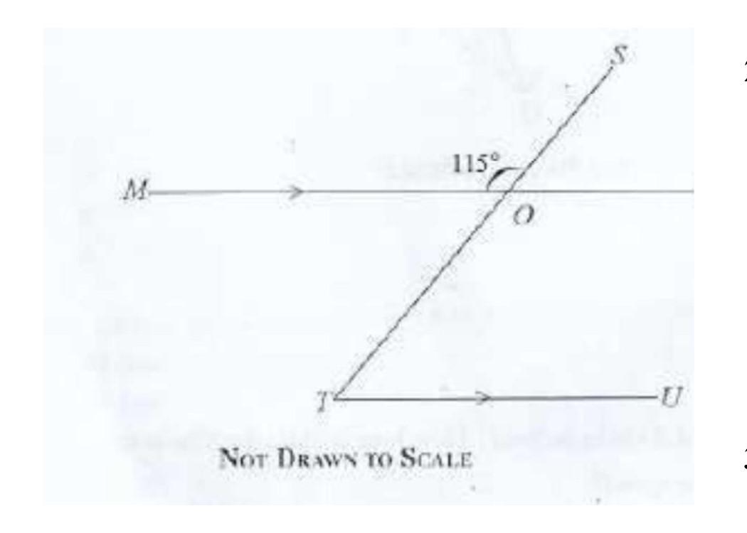
A. 65°.
B. 55°.
C. 45°.
D. 25°.
27. Given that r = (−3, −5) and t = (3, −5) are column vectors, find r + t.
A. (−6, 10).
B. (−6, −10).
C. (0, −10).
D. (6, 10).
28. A trader sold 90 oranges at 3 for GH₵0.75. How much did she get from selling all the oranges?
A. GH₵22.50.
B. GH₵67.50.
C. GH₵75.00.
D. GH₵225.50.
29. Express 72 as a product of prime factors
A. 2³ × 3².
B. 2² × 3³.
C. 2² × 3².
D. 2 × 3.
30. Simplify: 3a × 24ab.
A. 27ab².
B. 27a²b.
C. 72ab².
D. 72a²b.
31. Simplify (column vectors): (−2, 3) + (−1, 5)
A. (−3, 2).
B. (−1, 2).
C. (−3, 8).
D. (−1, −2).
32. Multiply 247 by 32
A. 6916.
B. 7804.
C. 7904.
D. 1235.
33. Evaluate: (0.07 × 0.02) ÷ 14.
A. 0.01.
B. 0.001.
C. 0.0001.
D. 0.00001.
34. In a class of 23 students, the girls were 7 more than the boys. How many boys were in the class?
A. 8.
B. 15.
C. 16.
D. 30.
35. Express 30 minutes as a percentage of 3 hours 20 minutes.
A. 12.5%.
B. 15%.
C. 16 2/3%.
D. 20%.
36. Find the Least Common Multiple (LCM) of 2, 3 and 5.
A. 6.
B. 12.
C. 24.
D. 30.
37. The simple interest on GHC 450.00 for 4 years is GHC 45.00, find the rate of interest.
A. 2.5%.
B. 10%.
C. 25%.
D. 6.5%.
38. Find the median of the following numbers: 46, 68, 34, 37, 76 and 81.
A. 35.5.
B. 57.
C. 67.
D. 68.
39. In the Venn diagram, M and N are subsets of the universal set U: the M-only region contains 5, 3 and 8; the overlapping region contains 2 and 7; the N-only region contains 1, 4, 6 and 9. (Use this information to answer Questions 39 and 40.) Find M∩N.
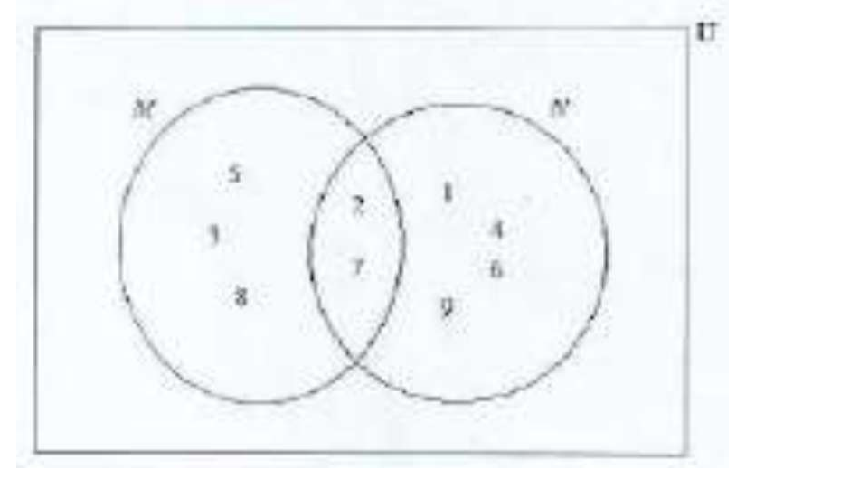
A. {7}.
B. {2, 7}.
C. {3, 5, 8}.
D. {1, 2, 3, 4, 5, 6, 7, 8, 9}.
40. How many members are in the set N (using the Venn diagram in Question 39)?
A. 2.
B. 3.
C. 4.
D. 6.

Answer Key
1. D {2, 4, 6, 8, 10, 12}.  2. C 3.44 × 10⁻⁴.  3. D −2.  4. D 0.0246.  5. D 7².  6. D 4.  7. C 1.  8. D (k + 2t)(x − 4).  9. A 2/5.  10. D 3/10.  11. A k = y²/(y − 1).  12. B 4.  13. D y = −2x + 5.  14. C 24.0 m.  15. B 1.5 m.  16. B 060°.  17. A {y: y > 5}.  18. D −1.  19. A 36.  20. B 40°. | 21. B 1 1/2 hrs.  22. C 2/11.  23. D 0.48.  24. C 28 cm.  25. C 28.  26. A 65°.  27. C (0, −10).  28. A GH₵22.50.  29. A 2³ × 3².  30. D 72a²b.  31. C (−3, 8).  32. C 7904.  33. C 0.0001.  34. A 8.  35. B 15%.  36. D 30.  37. A 2.5%.  38. B 57.  39. B {2, 7}.  40. D 6.

